Capstone Project Report: Demonstrating FTP vs. SFTP Security

BY: Suleiman Lukman

luqsule@gmail.com

ABSTRACT
File transfer is a common operation in modern computer networks, but the security of data in transit depends heavily on the protocol used. Traditional File Transfer Protocol (FTP) transmits data and credentials in plaintext, making it vulnerable to interception and unauthorized access. Secure File Transfer Protocol (SFTP), on the other hand, operates over the Secure Shell (SSH) protocol and provides encryption to protect both authentication credentials and file contents.

Introduction
This project demonstrates the security weaknesses of FTP and highlights how SFTP mitigates these risks through encryption. By capturing and analyzing network traffic using Wireshark, the project provides a practical comparison of both protocols and reinforces the importance of using secure communication methods in real-world environments.

Project Objectives
The objectives of this project were to:
- Demonstrate how FTP transmits data and credentials in plaintext
- Analyze FTP traffic to show how sensitive information can be intercepted
- Demonstrate how SFTP encrypts data during transmission
- Compare FTP and SFTP from a security perspective
- Reinforce the importance of secure file transfer protocols in network security

Scope of the Project
The scope of this project was limited to a controlled laboratory environment. Basic FTP and SFTP sessions were configured between a client and a server system. Network traffic generated during file transfers was captured and analyzed using Wireshark to observe and compare how data is transmitted in both protocols.

Methodology

Environment Setup
- A basic FTP user was configured on Kali to allow file transfers.
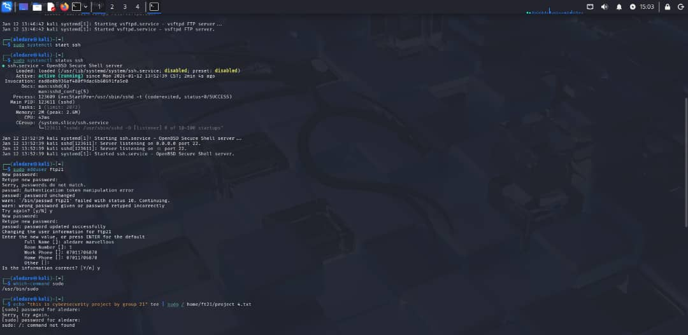
- An FTP and SFTP server and client were configured on Kali. The SFTP server uses SSH for secure file transfers.
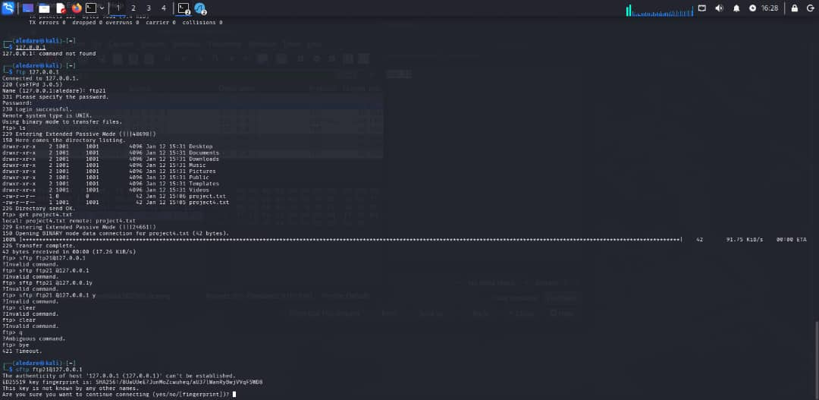
- A sample file was created and used for both FTP and SFTP transfers to ensure consistency in analysis.
- A file was created, named;”project4.txt” and saved to ftp21 directory. The file contained the message; “this is a cybersecurity project by group 21".
- This is the local loopack ftp-ip: inet- 127.0.0.1

FTP Traffic Capture and Analysis
Wireshark was used to capture network traffic during an FTP file transfer. The packet capture revealed:
- FTP command “get project4.txt” was used to initiate file transfer.
- The file transfer was captured on wireshark. User credentials visible directly in the packet payload.
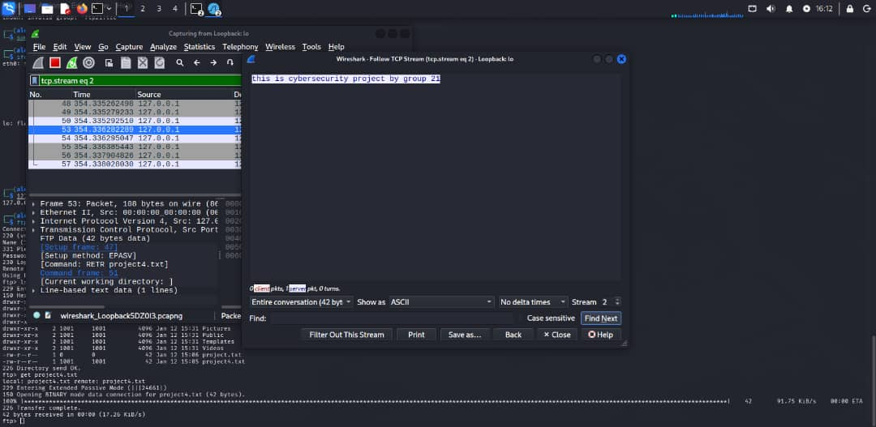
- File contents transferred without encryption, making them readable to anyone intercepting the traffic
These observations clearly demonstrated that FTP does not provide confidentiality and exposes sensitive information to network sniffing attacks.

SFTP Traffic Capture and Analysis
The same file transfer was repeated using SFTP.

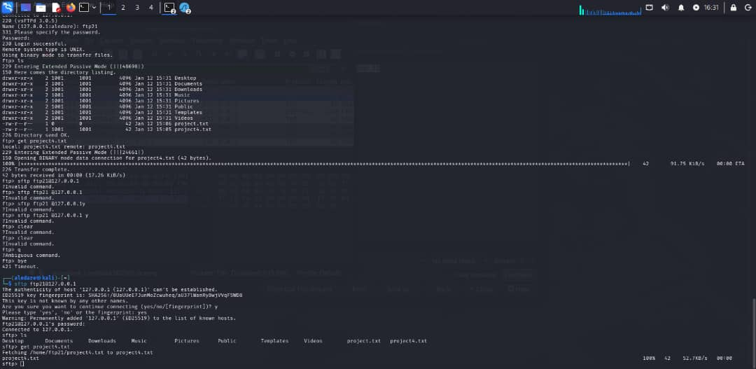
Network traffic was captured using Wireshark during the transfer. Unlike FTP:
- Authentication credentials were encrypted and not visible in the packet capture
- File contents were unreadable due to encryption
- The traffic appeared as encrypted SSH packets, preventing inspection of the transmitted data
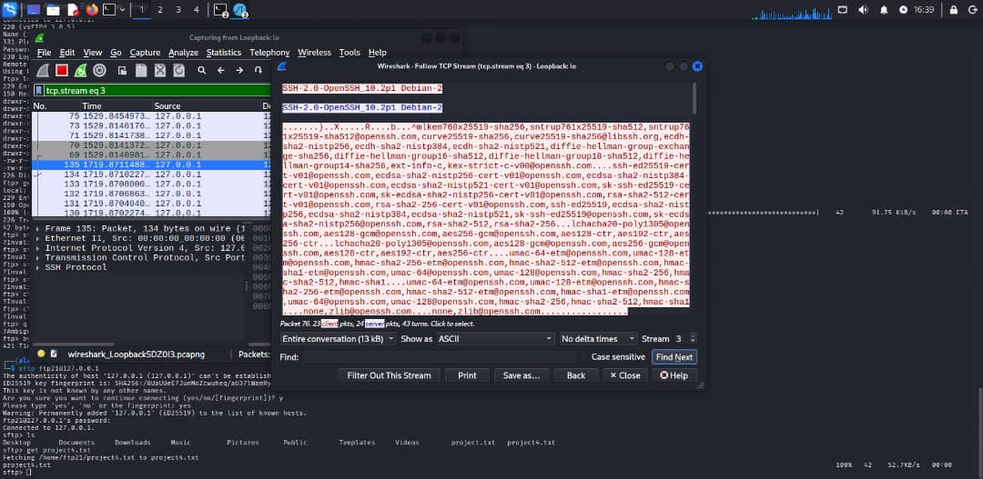
This confirmed that SFTP effectively protects data and credentials from interception.

Comparative Analysis

FTP Security Risks
- Transmits usernames and passwords in plaintext
- File contents can be intercepted and read
- Vulnerable to man-in-the-middle and packet-sniffing attacks
- Unsuitable for transferring sensitive or confidential data

SFTP Security Advantages
- Encrypts authentication credentials and file contents
- Uses SSH to provide confidentiality and integrity
- Protects data from interception and tampering
- Suitable for secure file transfers in real-world environments

Real-World Implications
The findings of this project demonstrate why FTP is considered insecure and largely deprecated in modern networks. Organizations handling sensitive data such as personal information, financial records, or system backups should avoid FTP and adopt secure alternatives like SFTP. Using encrypted protocols significantly reduces the risk of data breaches and unauthorized access.

Conclusion
This project successfully demonstrated the security differences between FTP and SFTP through practical packet capture and traffic analysis. The FTP capture revealed exposed credentials and readable file contents, confirming its lack of security. In contrast, SFTP traffic was fully encrypted, protecting both authentication information and data in transit.
The practical exercise reinforced the importance of encryption in network communication and highlighted how cryptography is applied in real-world secure file transfer protocols. This project provides a strong foundation for understanding secure communication practices in cybersecurity.
REFERENCES
Kahn Academy. (n.d.). Introduction to computer networks and protocols. Retrieved from general networking course materials.
Comer, D. E. (2018). Internetworking with TCP/IP: Principles, Protocols, and Architecture (6th ed.). Pearson Education.
RFC 959. (1985). File Transfer Protocol (FTP). Internet Engineering Task Force (IETF).
RFC 4251. (2006). The Secure Shell (SSH) Protocol Architecture. Internet Engineering Task Force (IETF).
RFC 4252. (2006). The Secure Shell (SSH) Authentication Protocol. Internet Engineering Task Force (IETF).
Scarfone, K., & Mell, P. (2012). Guide to Intrusion Detection and Prevention Systems (IDPS). National Institute of Standards and Technology (NIST).
Behl, A., & Behl, K. (2017). Cyberwar: The Next Threat to National Security and What to Do About It. Oxford University Press.

